How to submit your sitemap to Google Search Console

All formats limit a single sitemap to 50MB (uncompressed) or 50,000 URLs. If you have a larger file or more URLs, you must break your sitemap into multiple sitemaps. You can optionally create a sitemap index file and submit that single index file to Google. You can submit multiple sitemaps and sitemap index files to Google. This may be useful if you want to track the search performance of each individual sitemap in Search Console.
Sitemap file encoding and location: The sitemap file must be UTF-8 encoded. You can host your sitemaps anywhere on your site, but unless you submit your sitemap through Search Console, a sitemap affects only descendants of the parent directory. Therefore, a sitemap posted at the site root can affect all files on the site, which is where we recommend posting your sitemaps.

PURPOSE
Google Search Console is a free service offered by Google that helps you monitor, maintain, and troubleshoot your site's presence in Google Search results. You don't have to sign up for Search Console to be included in Google Search results, but Search Console helps you understand and improve how Google sees your site.
Search Console tools and reports help you measure your site's Search traffic and performance, fix issues, and make your site shine in Google Search results
- Verify site ownership. Get access to all of the information Search Console makes available. Learn more about how to verify your site ownership.
- Make sure Google can find and read your pages. The Index coverage report gives you an overview of all the pages Google indexed or tried to index in your website. Review the list available and try to fix page errors and warnings.
- Consider submitting a sitemap to Search Console. Pages from your site can be discovered by Google without this step. However, submitting a sitemap via Search Console might speed up your site's discovery. If you decide to submit it through the tool, you'll be able to monitor information related to it. Learn more about the Sitemaps report.
- Monitor your site's performance. The Search performance report shows how much traffic you're getting from Google Search, including breakdowns by queries, pages, and countries. For each of those breakdowns, you can see trends for impressions, clicks, and other metrics. If your traffic is going down, consider debugging the traffic drop, which can help you prioritize your efforts.
If you'd like to learn Search Console more in-depth, there are broadly two areas you could focus on. We provide here a list of reports that would be most relevant to web developers and those that would be most relevant to SEO specialists, digital marketers, and site administrators. While the groups have several intersection points, it's still useful to try and provide the most relevant reports for each group.

Helpful reports for SEO specialists, digital marketers, and site administrators
The following list includes the most useful Search Console reports to help you manage various aspects of how Google Search indexes, crawls, and serves your site.
- Learn if your site has any Google Search manual actions issued against it. If a site has a manual action, some or all of that site may not be shown in Google search results. The Manual Actions report shows any issues, in which section of your site, and where to learn more about it.
- Temporarily hide pages from Google Search. The Removals tool is a way to quickly remove content on your site from Google Search results. A successful request lasts only about six months, to allow time for you to find a solution to either allow the content to be seen or to remove it permanently.
- Tell Google about a site migration. If you move your website from one domain or subdomain to another, the Change of Address tool tells Google about your change, and helps to migrate your Google Search results from your old site to your new site.
- Review issues with your structured data implementation. The Rich result status reports show which rich results Google could or could not read from your site. You'll find details on errors that prevent showing your pages as rich results, warnings that might limit your appearance, and information on how to debug and fix issues.

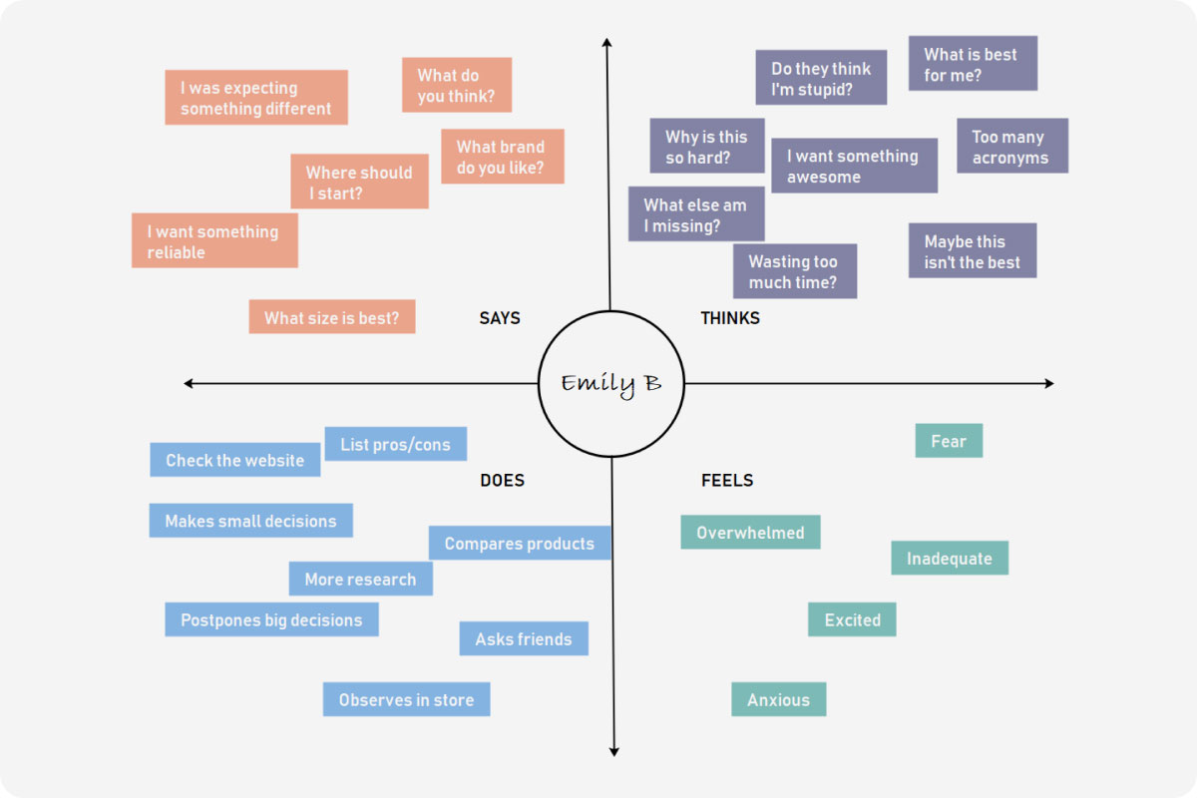

BRAIN STROMING

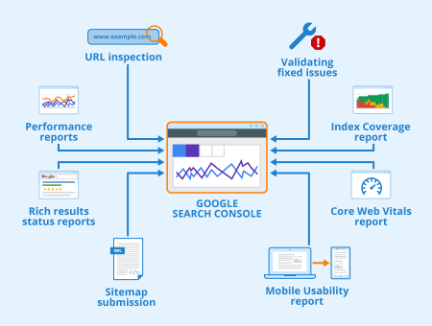

ADVANTAGE :

Improve Your Website’s Search Appearance

Make HTML Improvements

Increase Organic Search Traffic

Monitor Link Reports

Understand Google’s Index

Crawl Your Website

CONCLUSION

Google revolutionized the search engine game. It is hard to imagine daily life without the popular website. The Google search engine has dramatically changed the modern era because of its unique creation Page Rank, its influence over the way society thinks, and its impact on the world's economy.
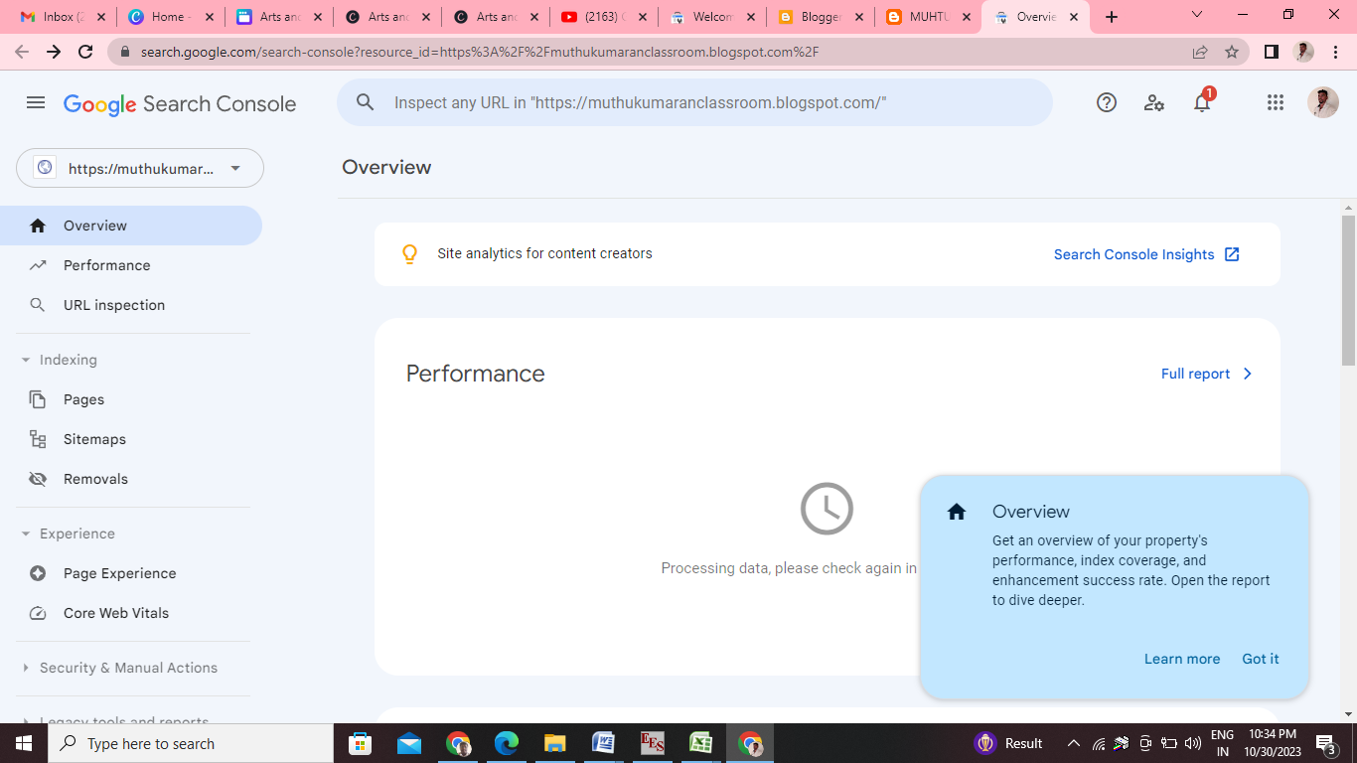

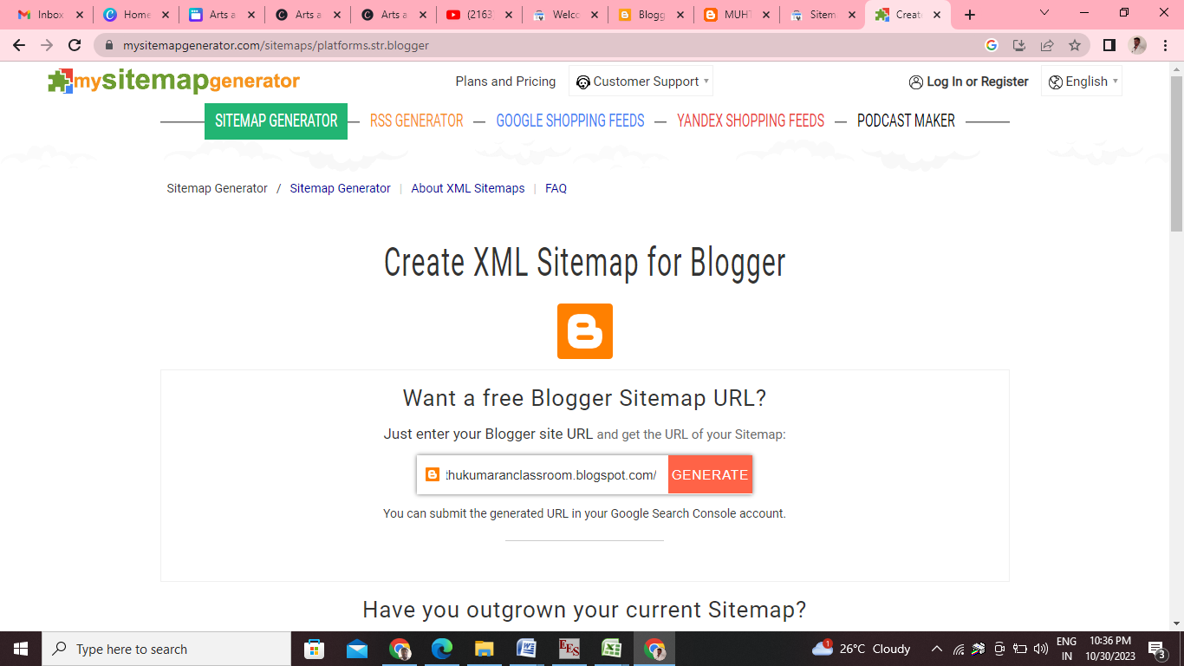
https://muthukumaranclassroom.blogspot.com/
https://muthukumaranclassroom.blogspot.com/2023/10/important-questions-papers.html

